Netflix Analytics Dashboard – Tableau

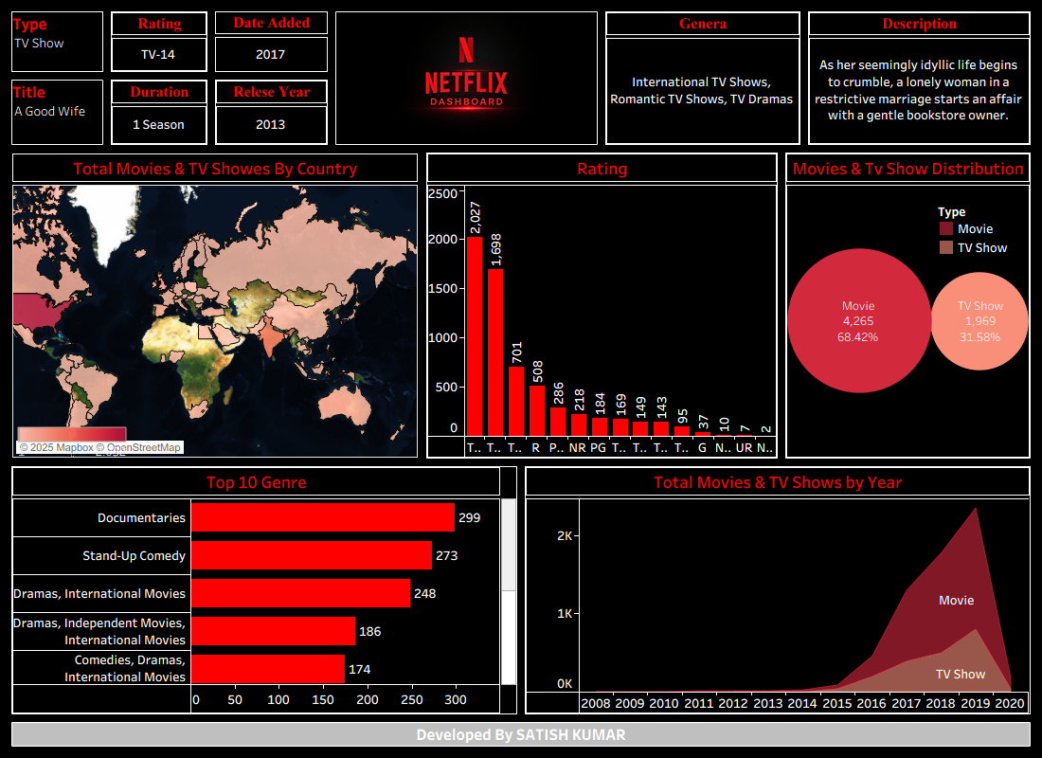

⭐ BRIEF EXPLANATION (For Interview)
Here is a short version you can speak directly:
“I built a Netflix Analytics Dashboard in Tableau to analyze global content trends. The dashboard includes maps, rating distribution charts, genre insights, movie vs TV show comparisons, and year-wise growth. I used a Netflix-style theme with black and red formatting for a professional UI. The dashboard helps users understand which countries produce the most content, which genres are most popular, what ratings dominate, and how Netflix’s library has grown over the years. I followed industry standards like container borders, padding, consistent color themes, structured layout, and data cleaning techniques to make it production-ready.”

1. Project Overview
The Netflix Analytics Dashboard is designed to provide a comprehensive view of Netflix’s content library using visual analytics. The dashboard helps users analyze global content distribution, ratings, genres, viewer preferences, and growth trends. It consolidates multiple datasets to give a unified view of movies and TV shows available on the platform.

2. Business Purpose
Netflix continuously expands its global content. To make data-driven decisions, stakeholders need insights on:
- What types of content are most common?
- Which countries contribute the most content?
- How content distribution varies by rating, genre, and year?
- How movies vs TV shows have grown over time?
This dashboard helps answer these questions with actionable visual insights.

3. Scope of Work

✔ In Scope
- Data cleaning & preparation
- Building interactive Tableau visualizations
- Designing filters & parameters
- Creating a high-quality Netflix-style UI (black & red theme)
- Insights generation

4. Dataset Details
Dataset | Source | Format | Size | Description
Netflix Titles Dataset | Kaggle | CSV | ~6,000 rows | Contains title details, type, rating, duration, country, year, genre, description

Key Columns Used
- Type (Movie/TV Show)
- Country
- Rating
- Genre
- Release Year
- Date Added
- Duration
- Description

5. Tools & Technologies
- Tableau Desktop public – dashboard development
- CSV – data preparation
- Tableau Maps – global heatmaps
- Custom UI Assets – Netflix-style logo & footer

6. Data Preparation
Performed the following steps:
- Handled Missing Values – for country, rating, and duration
- Normalized Fields – split country and genre into separate rows if multiple values exist
- Converted Formats – ensured Release Year and Date Added are in correct date formats
- Calculated Fields such as:
  - Content Count
  - Movie vs TV Show distribution
  - Top genres
- Joined/Blended data where required

7. Dashboard Components & Visualizations

7.1 Filters Section (Top)
Displays selected title details:
- Type
- Rating
- Date Added
- Title
- Duration
- Release Year
- Genre
- Description

7.2 Total Movies & TV Shows by Country (Map)
A heatmap showing global content distribution.
- Darker colors = more titles
- Helps identify content-producing regions
- USA, India, UK dominate content creation

7.3 Rating Distribution (Bar Chart)
Shows number of titles per rating category:
- TV-MA, TV-14, R rated content dominate
- Useful for monitoring age-appropriate content availability

7.4 Movies vs TV Shows Distribution (Bubble Chart)
- Large red bubble: Movies (approx. 68%)
- Light bubble: TV Shows (approx. 32%)
Shows Netflix still produces more Movies than TV Shows.

7.5 Top 10 Genres (Horizontal Bar Chart)
Top genres include:
- Documentaries
- Stand-Up Comedy
- International Movies
- Dramas

7.6 Total Movies & TV Shows by Year (Area Chart)
Shows how Netflix’s content library has evolved since 2008.
- Massive growth between 2015–2020
- Significant increase in movie production

7.7-Footer Section
A signature branding bar:
“Developed By SATISH KUMAR”
gives a professional project identity.

8. Design Principles Used
To match the Netflix theme, the following UI/UX choices were made:
- Black background + Red highlights
- Bold typography
- Container borders for clean layout
- Consistent spacing & padding
- Balanced layout using horizontal/vertical containers

9. Insights & Key Findings
- Movies account for 68% of Netflix content.
- TV shows expanded rapidly after 2016.
- The top contributing countries are USA, India, UK.
- Netflix heavily focuses on TV-MA and TV-14 rating categories.
- Popular genres include Documentaries, Stand-Up Comedy, Dramas.
- From 2015 onwards, Netflix’s content library shows exponential growth.

10. Conclusion
The Netflix Dashboard provides a complete 360-degree view of the platform’s content ecosystem.
It enables stakeholders to understand genre popularity, country contributions, content ratings, and production trends.
The dashboard is visually enhanced using Netflix’s signature theme, yet maintains industry-standard BI best practices.

